Homework 2 (PHYS-5319, Math-3), Due Thursday, June 29.

1. The velocity (v) of an electric bicycle with the power output (P) of the motor is described by the following differential equation:
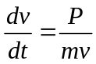
where m is the total mass (bicycle + rider). Given v(0)=4.0 m/s, P=400 Watt, m=70 kg, and Δt (or h) 0.1 sec., solve the v(t) by Euler method for time interval [0, 200]. compare the result with the exact solution 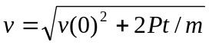.
(plot v against t)
(you may vary time step to see the accuracy variation)

2. Add in an air-drag term, −Av², on the right-hand of the equation in Problem 1, where A is proportional to the frontal area and the air density. Then solve for v(t) using A= 0.15 and compared the result to the solution with A=0.

3. Show that the Verlet algorithm to solve a 2nd-order ODE (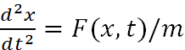 ) has an error in the order of magnitude of O(Δt⁴):
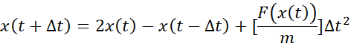.
Hint: using Taylor expansion for x(t+Δt) and x(t-Δt).

